How To: Correct Fitting Selection for Dual-line Systems
Since Pro V10.5 a change was made to allow for fractions of items to be placed into assemblies. This is useful when one riser is used to feed more than one lateral. To produce a correct bill of materials via Computer Selection of Fittings read the tips for assemblies with or without the riser included.

End Fed Dual Line with One Riser
Where the dual lines are end fed and there are 2 laterals per riser:


Assemblies Without the Riser:
1. Set the depth difference between the submain and lateral at half the depth of the actual depth.

2. Create a new LTO assembly containing the required fittings. Add ½ quantities of fittings (use 0.5 for the items where there is only 1 of). If a small amount of extra lateral is required between the tee and the elbows ensure that you have included this.
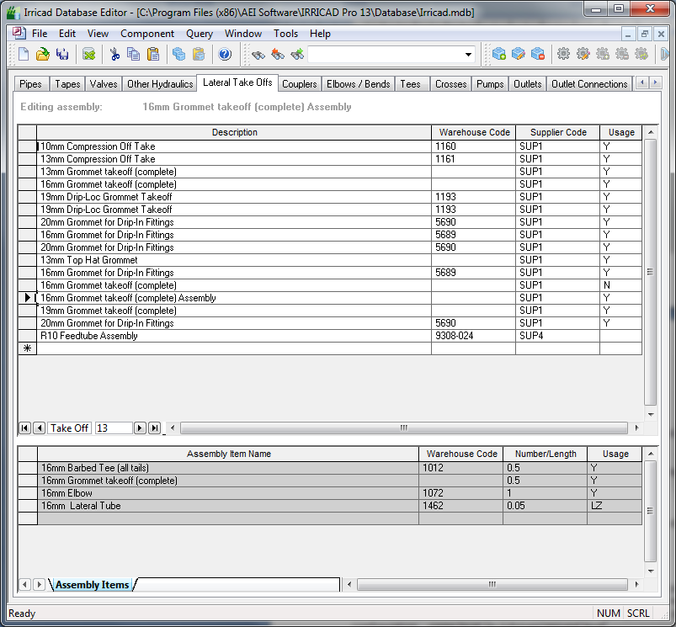

3. If there are more possible solutions which can be selected from the database that are not turned off set the "Fitting Type" for the lateral in Design|Pipe Fitting Matching Table to a unique code and set the "Minor Connection Type" in the assembly to the same unique code e.g., DLN2.

4. Run Computer Selection of Fittings.

Assemblies Including the Riser:
1. Set the submain depth to the same level as the tapes or spraylines.

2. Create an LTO assembly containing the required riser and fittings. Add ½ quantities of fittings (use 0.5 for the items where there is only 1 of) and add ½ the required length of the riser e.g., 0.3m for a 0.6m riser. If a small amount of extra lateral is required between the tee and the elbows ensure that you have included this.

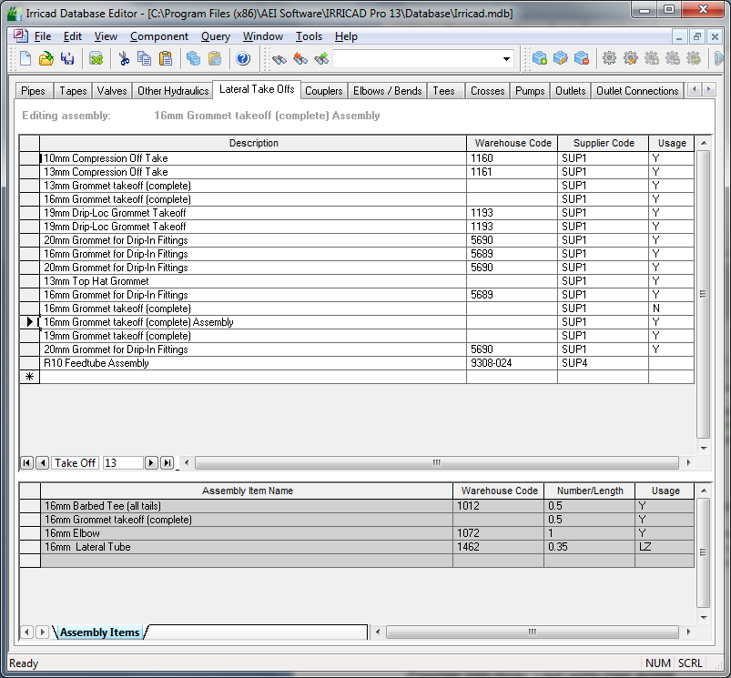

3. If there are more possible solutions which can be selected from the database which are not turned off set the "Fitting Type" for the lateral in Design|Pipe Fitting Matching Table to a unique code and set the "Minor Connection Type" in the assembly to the same unique code e.g., DLN2.

4. Run Computer Selection of Fittings.

Centre fed dual line with one riser
If the dual lines are centre fed where there are 4 laterals per riser:-
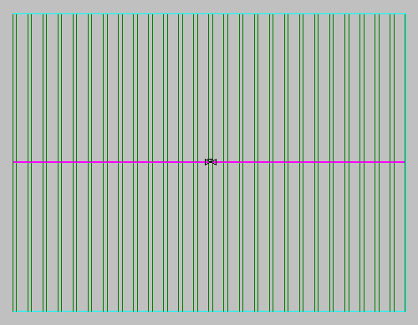

Assemblies Without the Riser:
1. In the Design|Pipe Fitting Matching Table change the fitting type of the tapes or sprayline pipe to DLN4.

2. Create an LTO assembly with ¼ of the required items using decimal fractions e.g. 0.25.
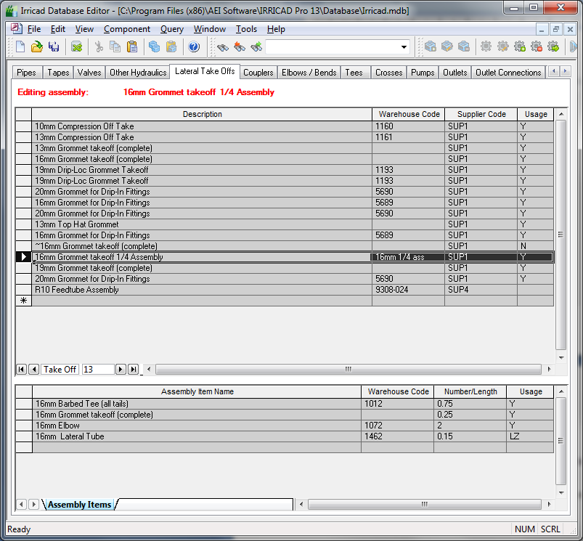

3. Set the "Minor Connection Type" to DLN4.

4. Set the sbmain depth to ¼ of the actual depth.

5. Run Computer Selection of Fittings.

A Combination of End Fed and Centre Fed?
In case there are laterals which do not share a riser, or have some end fed and some centre fed blocks set the "Scope" to Design Only . Run fitting selection on each block individually by setting the "Scope" to use Design + BOM and use the above methods as applicable.

